FIELD REPORT
Introduction
Place: Ogur Seed Secondary School
Location: Lira district
Date of visit: 31st August 2026
- General observations
- The school did not have an updated asset register, inventory book, or delivery notes available to support the verification exercise.
- Access to some blocks, including the Science Laboratory, Multipurpose Building, and ICT/Library block, was restricted because the keys were not available at the time of the visit.
- The ICT equipment reportedly received by the school from both the district and the school-level supply process was not accompanied by delivery notes, making it difficult to establish the details and quantities of equipment originally supplied.

2. Special notes
The verification exercise was constrained by the absence of key asset documentation, including the asset register, inventory book, and delivery notes, as well as limited access to some blocks such as the Science Laboratory, Multipurpose Building, and ICT/Library block. Additionally, delivery documentation for ICT equipment reportedly received through the district and school was unavailable, making it difficult to fully reconcile and confirm the assets supplied under UGIFT.

The table below illustrates some physical status of the verified assets with photographic evidence.
Table XXX: Physical verification photos

Public address system | 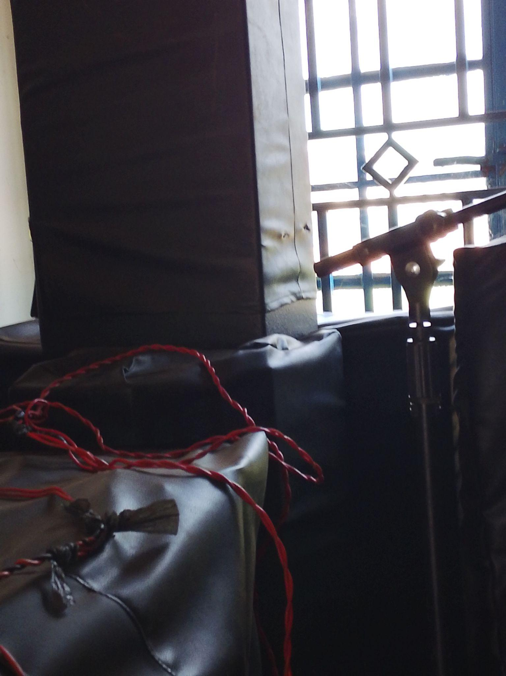
Engraved chair | 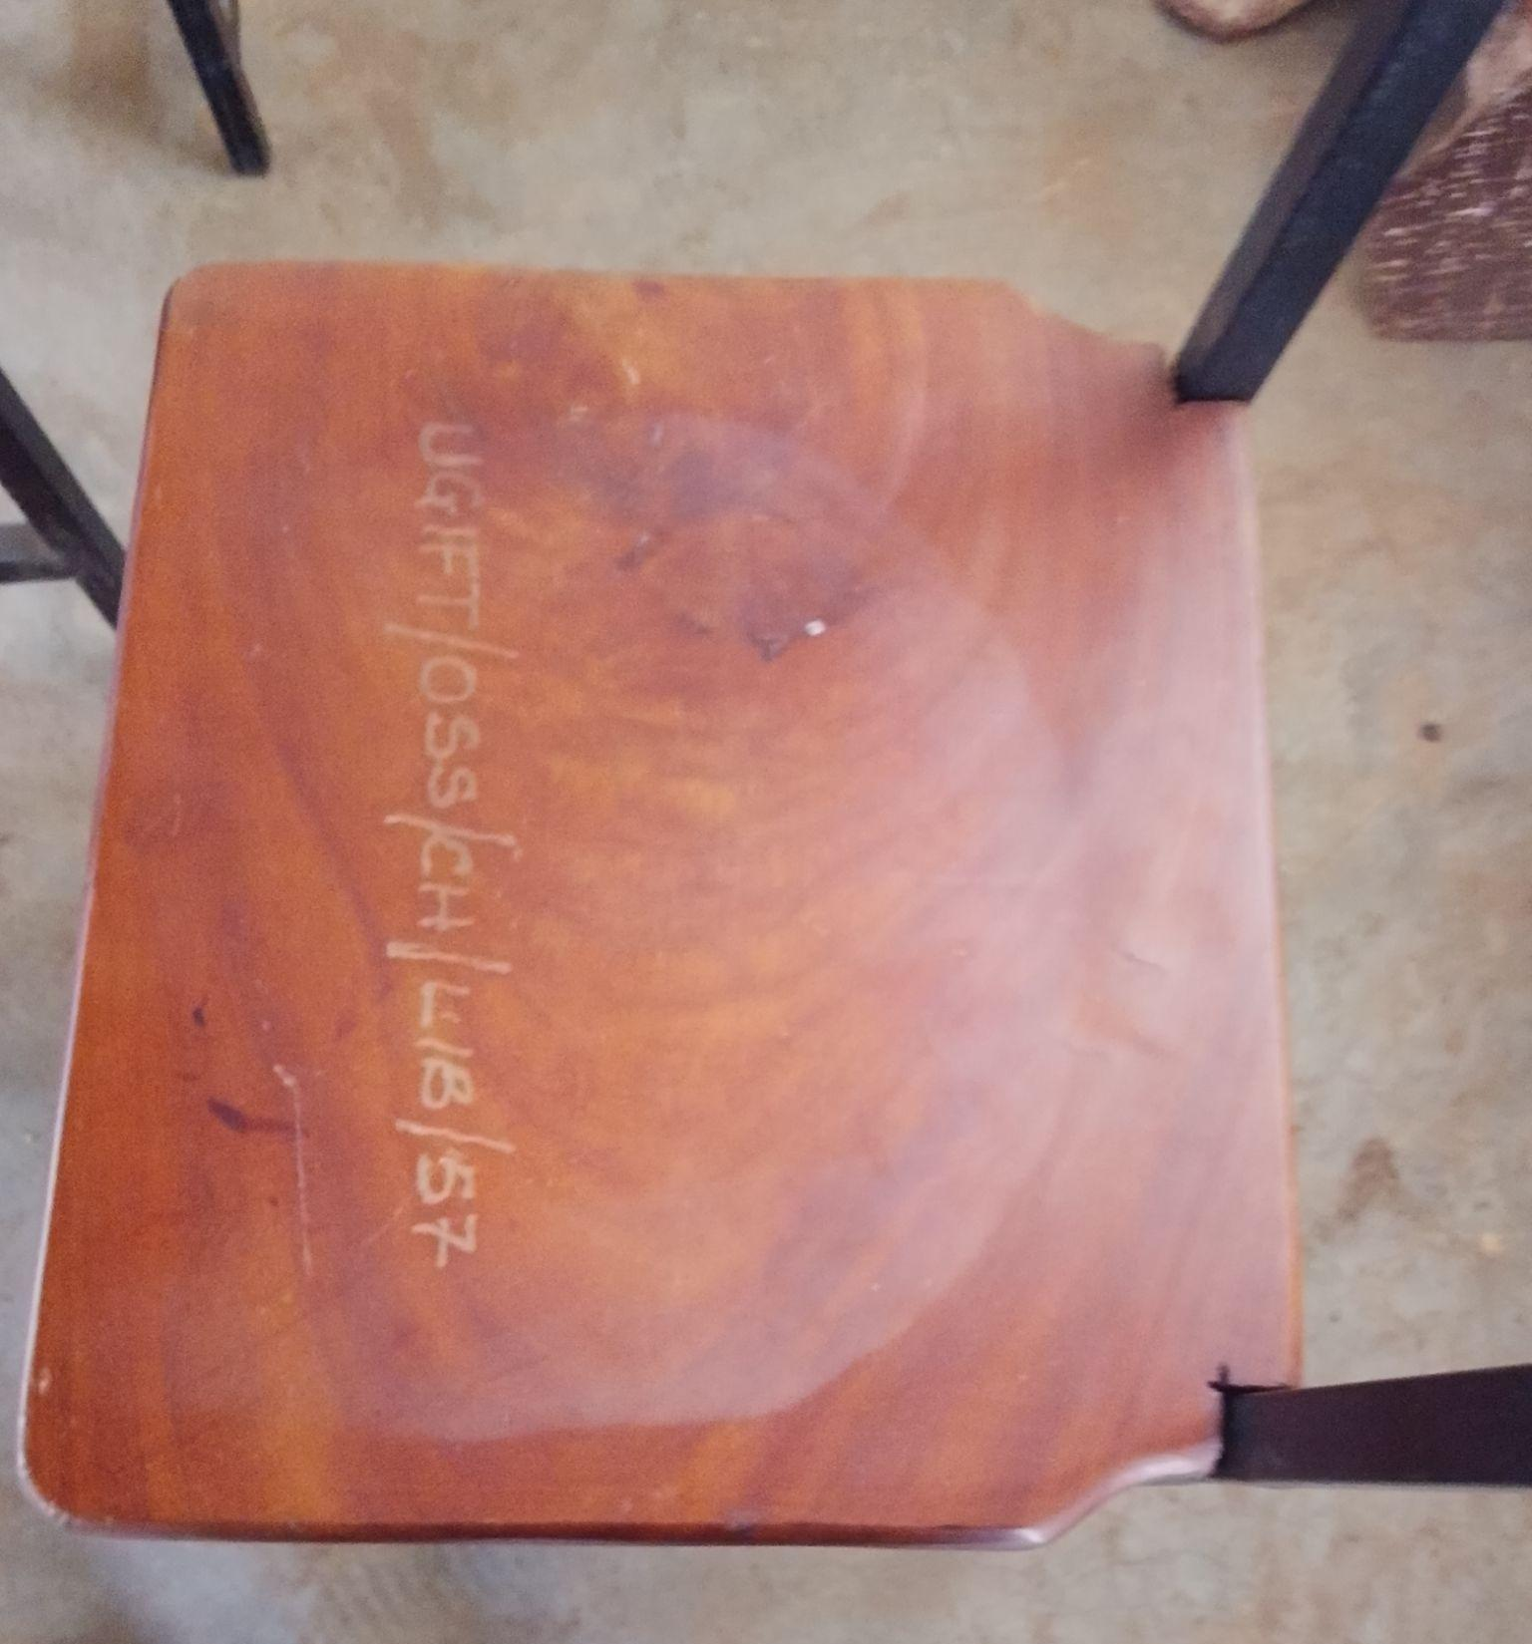
Pit latrines | 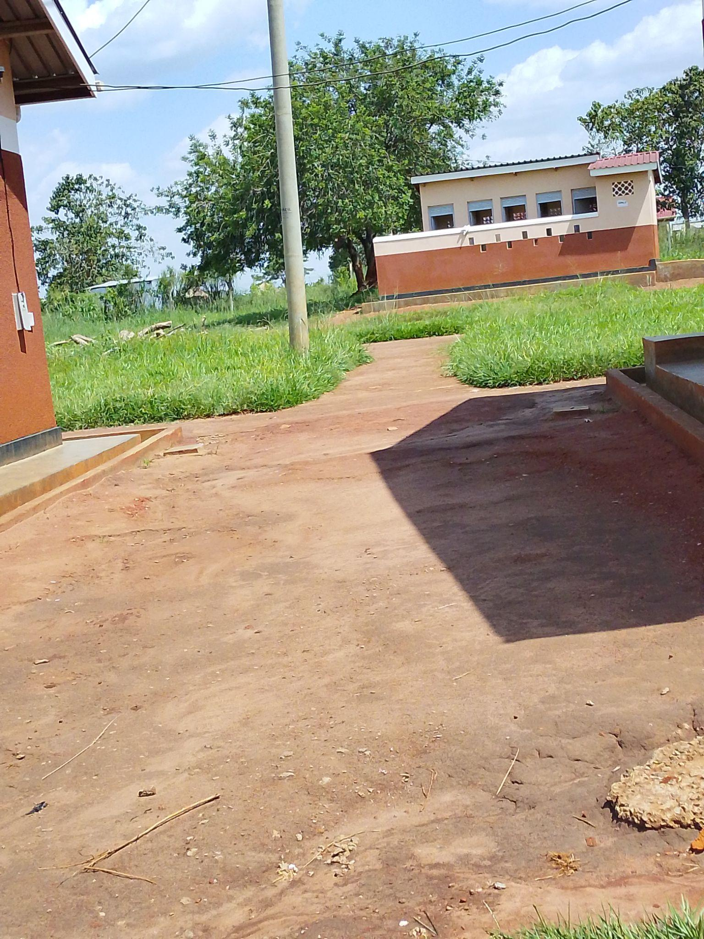
Classroom with desks | 